EXPT NO: 8 | TRAIN A SIMPLE AUTOENCODER FOR DIMENSIONALITY REDUCTION AND FEATURE LEARNING
DATE: 1.11.2026

PRE-LAB QUESTIONS (PROVIDE BRIEF ANSWERS TO THE FOLLOWING QUESTIONS)

- What is an autoencoder?
An autoencoder is an artificial neural network used to learn and compress data. It tries to reproduce the original input as accurately as possible. It consists of two main parts: an encoder and a decoder.
- What are the roles of the encoder and decoder in an autoencoder?
• Encoder: Compresses the input data into a smaller representation.
• Decoder: Reconstructs the original data from the compressed representation.
Together, they help the network learn important features of the input data.

- What is dimensionality reduction?
Dimensionality reduction is the process of reducing the number of features or variables in a dataset. It removes unnecessary information while keeping important features. This makes data easier to store, process and analyze.
- What is meant by latent representation or latent space?
Latent representation is the compressed form of the original input data. It contains the most important features learned by the encoder. Latent space is the space where these compressed representations are stored.
- Why is reconstruction loss used when training an autoencoder?
Reconstruction loss measures the difference between the original input and the reconstructed output. It helps the autoencoder understand how accurately it has recreated the input. The model tries to minimize this loss during training.
AIM
To implement and train a simple autoencoder using a dataset such as MNIST, learn a lower-dimensional representation of the input data, and evaluate the model by reconstructing the input samples and visualizing their latent representations.

SOFTWARE REQUIREMENTS
- Python
- TensorFlow / Keras
- Google Colab or Jupyter Notebook
- GitHub
- NumPy
- Matplotlib
- Pandas (optional)

OBJECTIVES
Students will be able to:
- Understand the architecture and working of autoencoders.
- Differentiate between the encoder, latent representation, and decoder.
- Prepare and preprocess a dataset for autoencoder training.
- Build an autoencoder using appropriate neural network layers.
- Train the model using reconstruction loss.
- Perform dimensionality reduction and extract latent features.
- Visualize original and reconstructed samples.
- Evaluate reconstruction performance using loss values and visual inspection.

PROCEDURE
PART A: DATASET PREPARATION AND PREPROCESSING
Perform the following tasks:
- Load the MNIST handwritten digit dataset using TensorFlow/Keras.
- Explore the dataset and check the number of training and testing images and their dimensions.
- Display sample images from the dataset.
- Convert pixel values to floating-point values and normalize them to the range [0, 1].
- Flatten each 28 × 28 image into a 784-dimensional input vector for a basic dense autoencoder.
- Prepare training and testing data. Use the input images as both input and target output because the autoencoder learns to reconstruct its input.
(CODE: CONATAINS STUDENT ROLL NOS
SCREENSHOT OF CODE
SCREENSHOT OF OUTPUT)

PART B: IMPLEMENTING THE ENCODER AND DECODER
Perform the following tasks:
- Define the input layer with 784 features.
- Build the encoder using one or more Dense layers to map the input to a smaller latent dimension, such as 32 features.
- Build the decoder using Dense layers to map the latent representation back to 784 output values.
- Use suitable activation functions, such as ReLU for hidden layers and Sigmoid for the final layer.
- Combine the encoder and decoder into a single autoencoder model.
- Display the encoder, decoder, and autoencoder model summaries.
(CODE: CONATAINS STUDENT ROLL NOS
SCREENSHOT OF CODE
SCREENSHOT OF OUTPUT)

PART C: COMPILING AND TRAINING THE AUTOENCODER
Perform the following tasks:
- Compile the autoencoder using an optimizer such as Adam.
- Select an appropriate reconstruction loss, such as binary cross-entropy or mean squared error.
- Train the model by supplying the input images as both input data and target data.
- Use a suitable batch size and number of epochs. For example, use a batch size of 256 and 10 epochs.
- Validate the model using the test dataset or a validation split.
- Record training and validation loss for each epoch.
- Plot the training and validation loss curves to observe the reconstruction performance.
(CODE: CONATAINS STUDENT ROLL NOS
SCREENSHOT OF CODE
SCREENSHOT OF OUTPUT)

PART D: DIMENSIONALITY REDUCTION, FEATURE LEARNING AND RECONSTRUCTION
Perform the following tasks:
- Use the trained encoder to convert test images into lower-dimensional latent feature vectors.
- Display the original input dimension (784) and latent dimension (for example, 32).
- Pass the latent vectors through the decoder to reconstruct the images.
- Display original images and their corresponding reconstructed images side by side.
- Compare the original and reconstructed images and comment on the information retained or lost.
- Optionally, use PCA or t-SNE to visualize latent features in two dimensions, if covered in the course.
- Save the trained model or reconstructed images if required.
CODE:
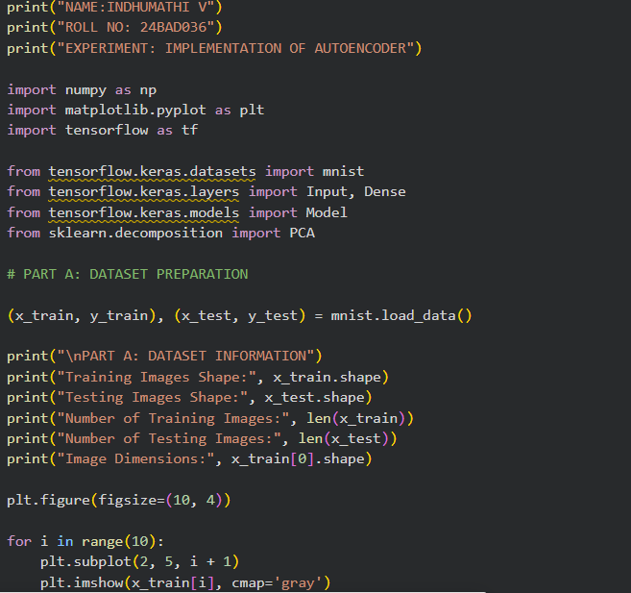
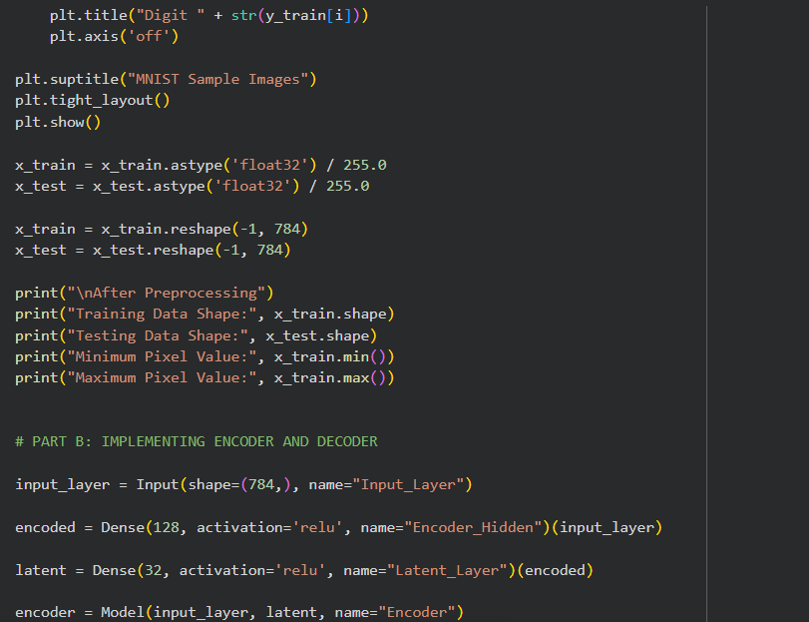

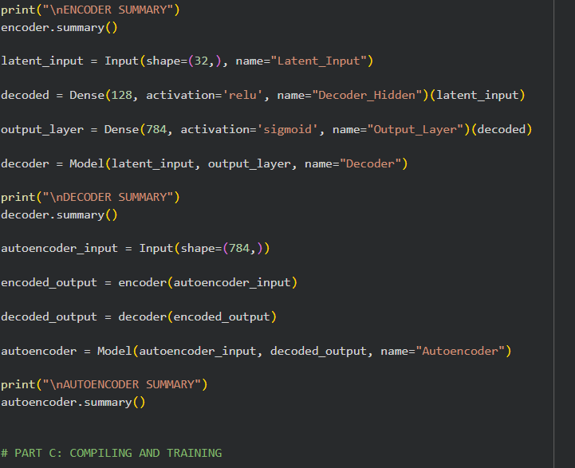
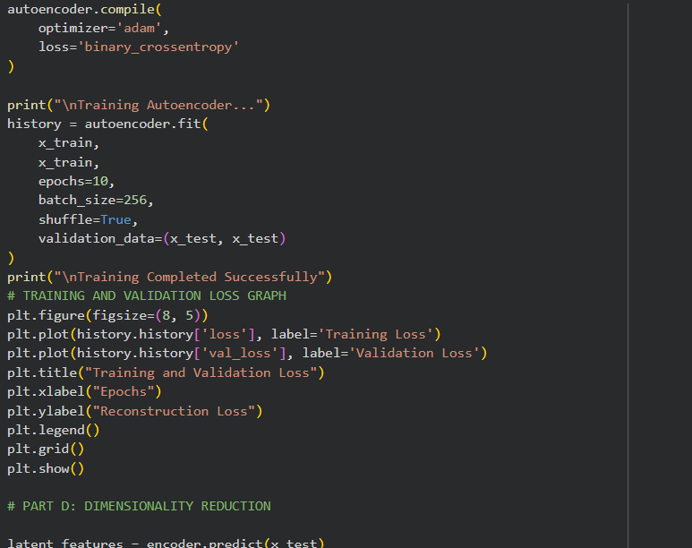
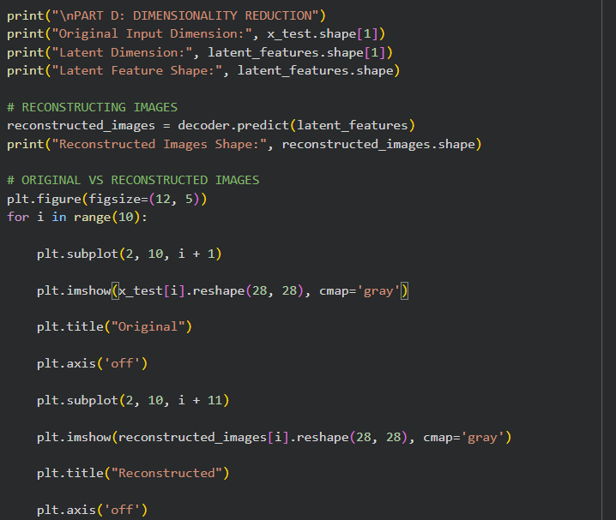

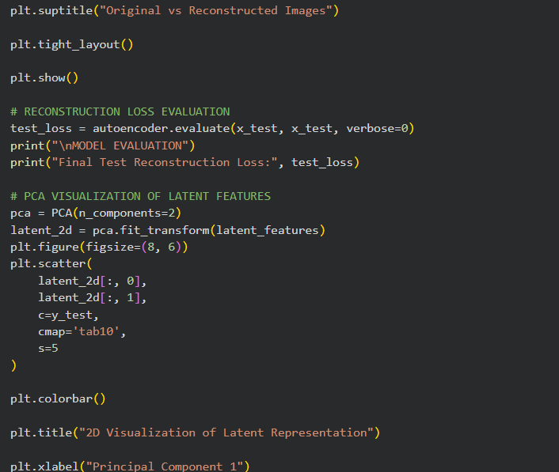
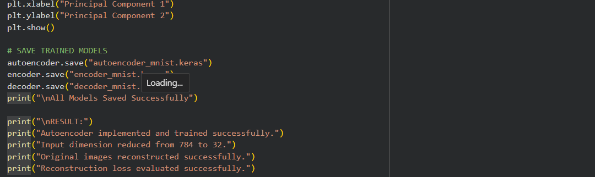

OUTPUT:
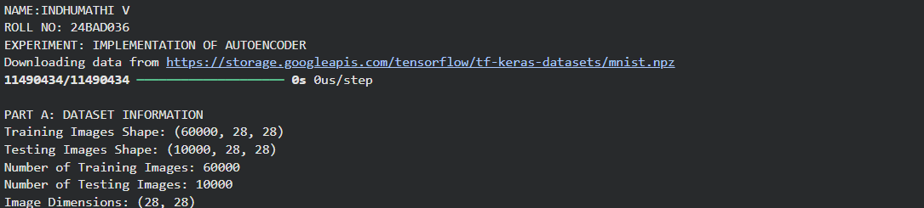
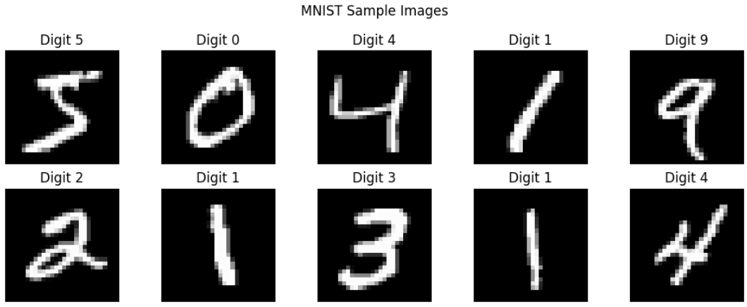
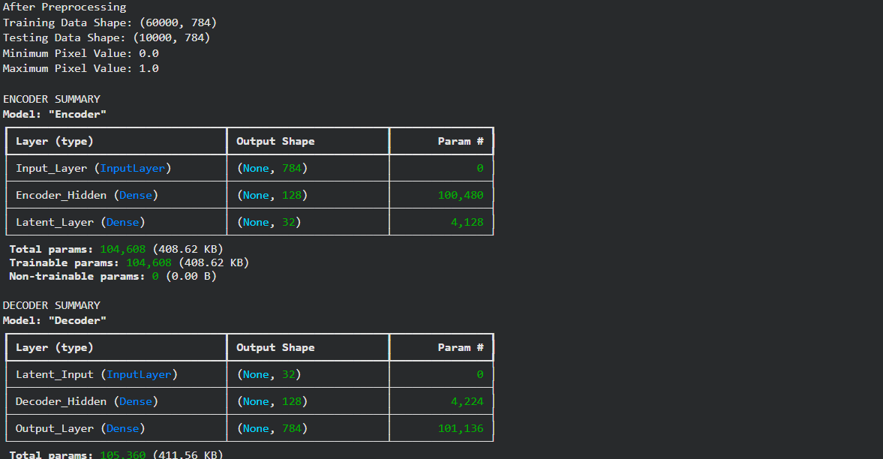

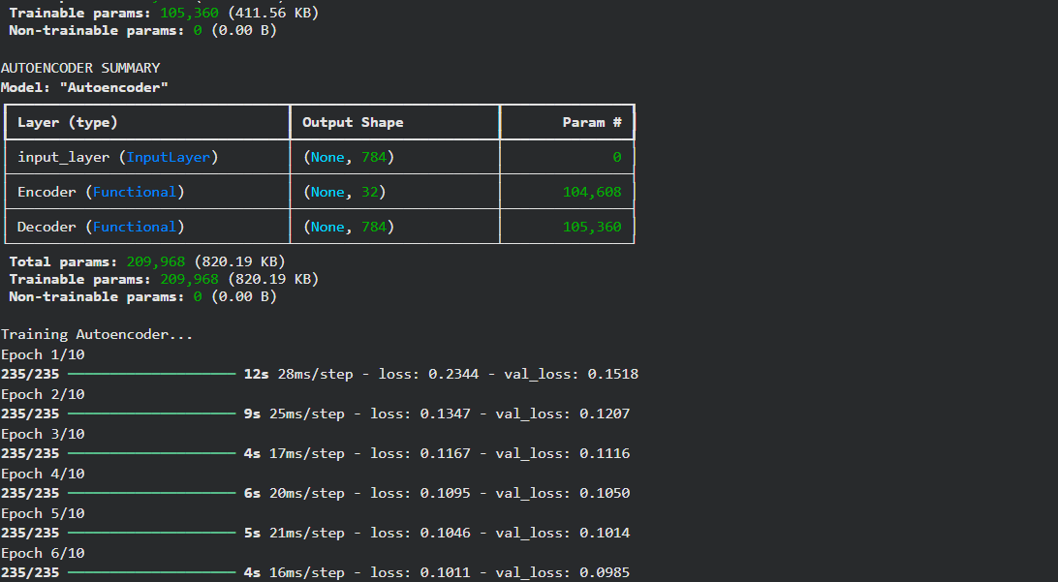
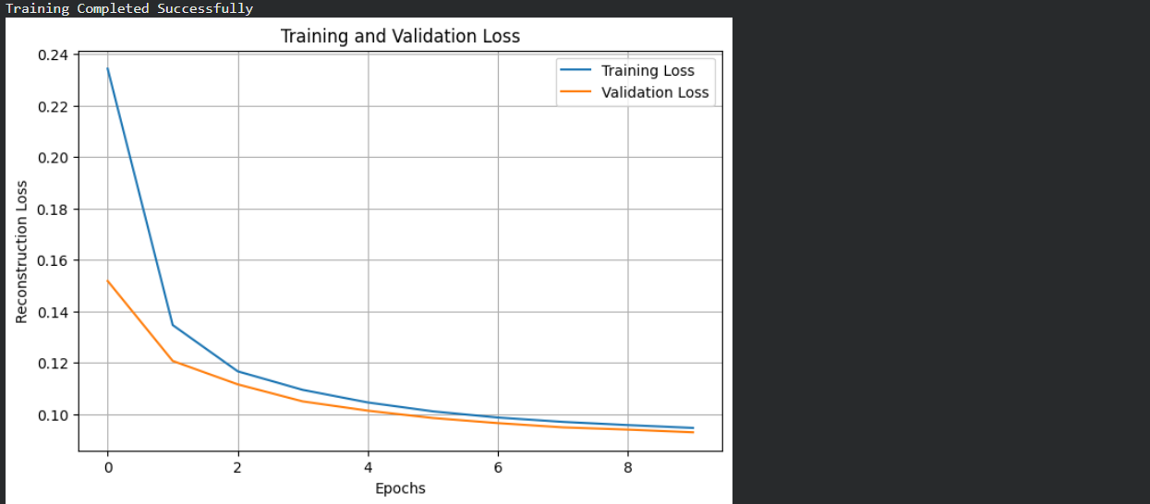
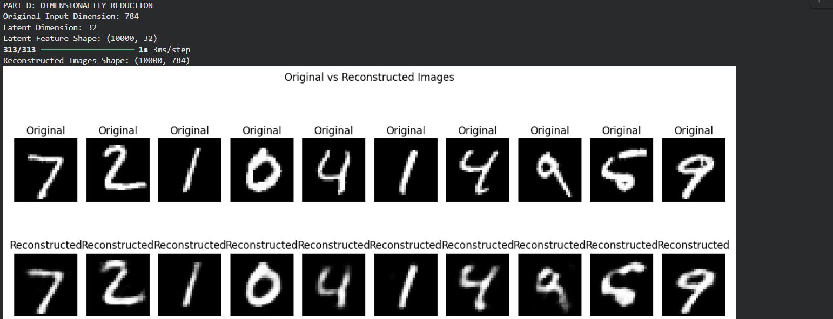

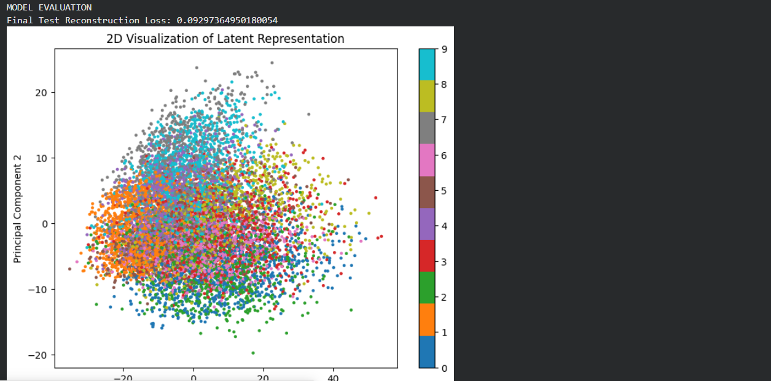
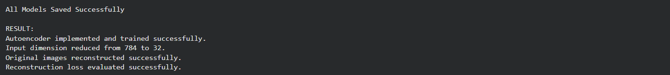

EXPECTED OUTCOME
Students will understand the architecture and working of a simple autoencoder and the roles of its encoder, latent representation, and decoder.

POST-LAB QUESTIONS (PROVIDE BRIEF ANSWERS TO THE FOLLOWING QUESTIONS)

1. What is the main purpose of an autoencoder?
The main purpose of an autoencoder is to compress data and reconstruct it as closely as possible to the original. It learns important features from the input data while reducing unnecessary information. It is commonly used for feature extraction and data compression.

2. How do the encoder and decoder differ?
The encoder compresses the input data into a smaller representation. The decoder takes this compressed data and reconstructs the original input. The encoder reduces the data size, while the decoder restores the data.

3. What is a latent representation?
Latent representation is the compressed form of the original input data. It contains the important features extracted by the encoder and is stored in the latent space. It helps the model understand the essential information in the input.

4. How does an autoencoder perform dimensionality reduction?
An autoencoder reduces the number of input features by compressing them into a smaller latent representation. This smaller representation retains the most important information from the original data. It helps reduce data complexity and storage requirements.

5. Why are the input images also used as target outputs during training?
Autoencoders learn without requiring separate labelled data. The input image is used as the target output so that the model learns to reconstruct the same image as accurately as possible. This is called unsupervised learning.

6. What does reconstruction loss measure?
Reconstruction loss measures the difference between the original input and the reconstructed output. A lower reconstruction loss indicates better reconstruction accuracy. It helps the model improve its performance during training.

7. What may happen if the latent dimension is too small?
If the latent dimension is too small, the autoencoder may lose important information during compression. As a result, the reconstructed output may be unclear or inaccurate. Important features of the original data may not be recovered.

8. Mention one real-world application of autoencoders.
One real-world application is image denoising. Autoencoders remove unwanted noise from images and produce clearer images. They can also be used in medical image processing to improve image quality.

SUGGESTIONS FOR DATASETS
- MNIST Handwritten Digits – https://www.tensorflow.org/datasets/catalog/mnist
- Fashion-MNIST – https://www.tensorflow.org/datasets/catalog/fashion_mnist
- CIFAR-10 – https://www.tensorflow.org/datasets/catalog/cifar10 (requires adapting the model for image inputs)

ASSESSMENT
Description | Max Marks | Marks Awarded
Pre Lab Exercise | 5
In Lab Exercise | 10
Post Lab Exercise | 5
Viva | 10
Total | 30
Faculty Signature

